
Development Request
Aria Systems
Enhance the Classification Setup screen

Custom Program # : refer to C# 102451

Screen Template

Product: | Aria 2.7
Module: | IC
Customer name: | GMA
Screen Name: | Style Classification Setup
Installed Modules: | All modules except PS.
Parameters setting: | (see the Setting file)

Details Section
Screen Name: Style Classification Setup
Existing Initial situation:
In reference to CP# 102451, Style Classification Setup screen, the mentioned screen is currently allow the user to setup the different style’s Categories, Classes, Sub Classes,… and link each level to the upper level to use this relation later on in the Style screen to classify each style in Aria.
Due to the nature of GMA styles (fashion accessories), it has been found that using this screen is kind of complicated due to the fact that many levels need to be linked to each others and many elements under each level need to be filled.

Screen Objective:
- To facilitate the way we enter the link between Groups, Categories, Classes, Sub Classes,...in a way that carry automatically the elements under each level and apply it to all the upper level elements.

Description:

Currently, when the user selects a Department and a Group, a message popup: “Do You Want To Copy from another Group? Y/N”. The below enhancement will apply only if the user selects “NO” to the previous message to create the Group levels from scratch.

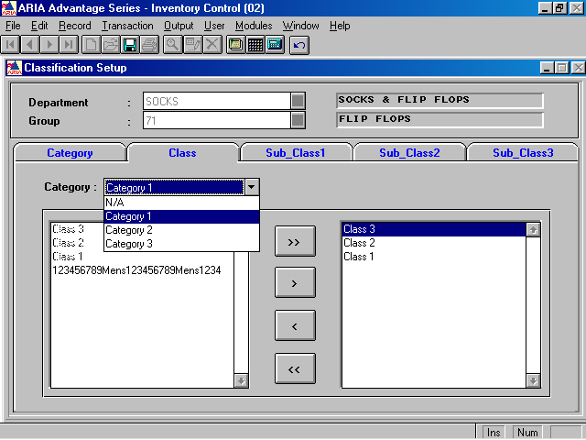

Once the user selects the required Categories and move on to the Class folder, the user will select the required Classes under the 1st Category (as shown, Category1 includes Class1,2,3). The program then will copy these selected classes to all other Categories selected previously by default (as shown, it’ll copy to Category1,2,3).

The same concept above will apply on Sub-Class1, Sub-Class2, Sub-Class3 folders.

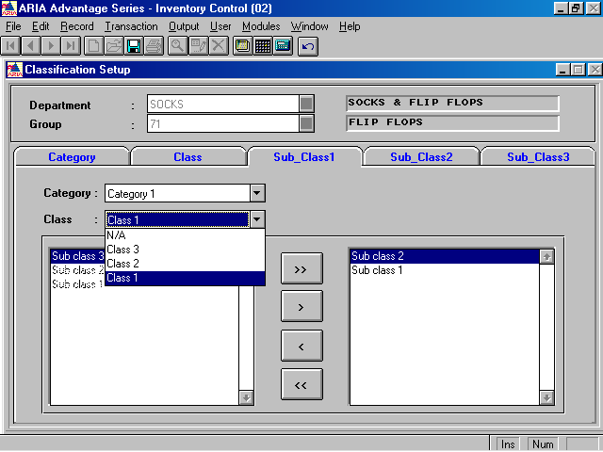
Once we select Category1, Class1 and choose the required Sub Classes, it should apply automatically to all other levels in a compound relation as follow:
Category1/Class2
Category1/Class3

Category2/Class1
Category2/Class2
Category2/Class3

Category3/Class1
Category3/Class2
Category3/Class3 and so on for the other folders Sub-Class2, Sub-Class3.
Hi Tarek,

I installed this fix. It works fine in the Add mode. In the Edit mode, it doesn't copy the new item inserted to all levels. We thought about it and we need to do it as follow:

If we EDIT existing Group:
- If the user insert a new item in any level (Category, Class,..), an option message will popup "Do You Want To Copy % to All levels?" Y/N, where the "%" reflect the Category, Class, Subclass,...
If Yes, it'll copy to all levels. If No, it'll apply to the selected level item only.

- The same concept if the user choose to remove an item. an option message will popup "Do You Want To Delete % from All levels?" Y/N, and the program acts accordingly.

Pls advise with any question and send us back asap.

Thanks
Alaa
------------------------------------------------------------------------------------------

